**Creating a Node-Red UI to view data in Separate Graphical form**

|  |  |
| --- | --- |
| Date | 13 November 2022 |
| Team ID | PNT2022TMID42967 |
| Project Name | Gas Leakage Monitoring and Alerting  System for Industries. |

After creating the Node Red Web Application, we have to install the UI interface in

Node Red.

* Copy and pasting the URL of the NodeRed in the new tab

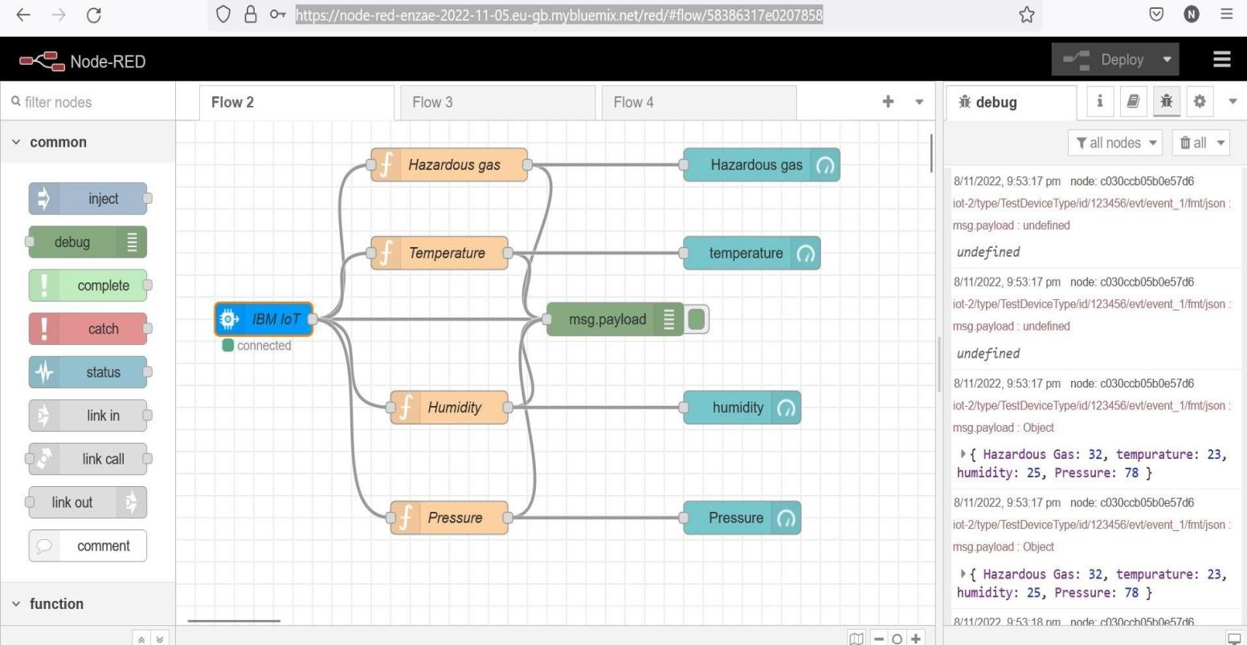

Output :

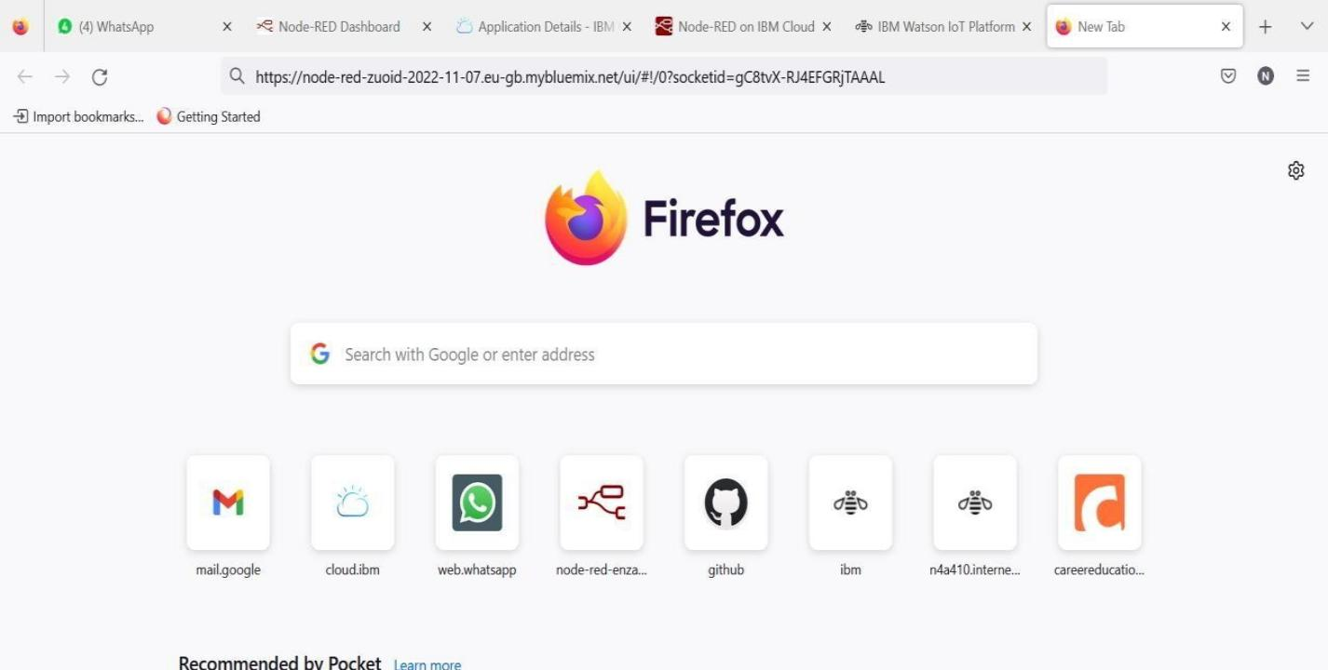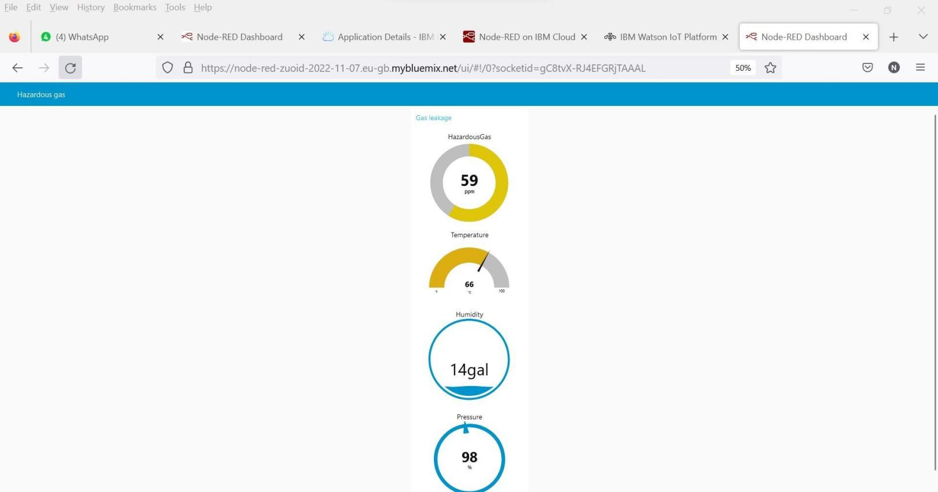

Link: https://node-red-zuoid-2022-11-10.eu-gb.mybluemix.net/ui/#!/0?socketid=gC8tvX-RJ4EFGRjTAAAL

**Result:**

Thus, the Node Red UI is created successfully.